Hi guys!

Regarding the website content, is it ok if I add 3-5 animals of each order and not add all the order types-just around 10-20 (there are more than 50) for the presentation for Grant? If he likes the format, I’ll add content for the rest of them but I think it’s pretty useless to concentrate too much on this for the first deliverable.

Primates:

***Greater Bush Baby***

**Life span**  
15 years.

**Physical description**  
Thick-tailed greater bush babies have brown or grey fur, with exceptionally large ears, a pointed muzzle and large eyes. They are strongly built, with broad hands and feet adapted for grasping, with opposable first digits. As their name suggests, they have thick, bushy tails.

http://www.bbc.co.uk/nature/wildfacts/images/page_div.gif

**Distribution**  
They range across Somalia, Kenya, Tanzania, Rwanda and south to South Africa.

http://www.bbc.co.uk/nature/wildfacts/images/page_div.gif

**Habitat**  
Thick-tailed greater bush babies live in woodland, forested savannah, plantations and bamboo thickets.

http://www.bbc.co.uk/nature/wildfacts/images/page_div.gif

**Diet**  
They mostly feed on tree exudates and fruit, but they also take a small amount of animal prey, including invertebrates and small birds, reptiles and mammals.

http://www.bbc.co.uk/nature/wildfacts/images/page_div.gif

**Behaviour**  
They are nocturnal and arboreal, preferring the upper levels of the forest. Rather than leaping through the canopy, they tend to run along the branches.

http://www.bbc.co.uk/nature/wildfacts/images/page_div.gif

**Reproduction**  
Thick-tailed greater bush babies breed between May-October. After a gestation period of 126-136 days, females give birth to 1-3 offspring. The mothers carry the infants in their mouth and later on the back.

http://www.bbc.co.uk/nature/wildfacts/images/page_div.gif

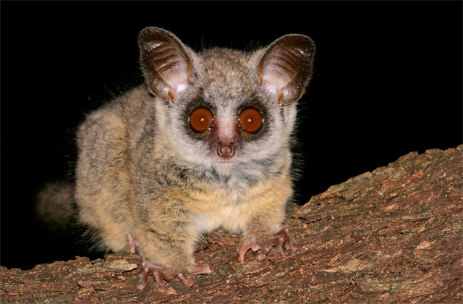

**Patas Monkey:**

Patas monkeys are quadrupedal and are considered to be the fastest primate, running at speeds of 55km/hr.

**Life span**  
21 years.

**Physical description**  
These are large monkeys with long, slender limbs. The back and sides are reddish brown and the under-parts are grey/white. They have a white moustache and the face varies from black to light grey. They have shaggy, grey-streaked shoulders and males have a bright blue scrotum.

http://www.bbc.co.uk/nature/wildfacts/images/page_div.gif

**Distribution**  
They range from West Africa to Ethiopia, Kenya and Tanzania.

http://www.bbc.co.uk/nature/wildfacts/images/page_div.gif

**Habitat**  
They inhabit acacia woodland and dry savannah.

http://www.bbc.co.uk/nature/wildfacts/images/page_div.gif

**Diet**  
Patas monkeys feed on fruit, seeds, grass, insects, lizards and bird eggs.

http://www.bbc.co.uk/nature/wildfacts/images/page_div.gif

**Behaviour**  
Patas monkeys live in groups of 5-34, typically consisting of one male and many females. The troop is led by females, and males are non-territorial, ignoring the female's boundary disputes. They are diurnal and mostly terrestrial, although they do also spend time in the trees. Patas monkeys are quadrupedal and are very fast runners.

http://www.bbc.co.uk/nature/wildfacts/images/page_div.gif

**Reproduction**  
After a gestation period of 167 days, females give birth to one infant between December and February. The infants are black until they are two months old.

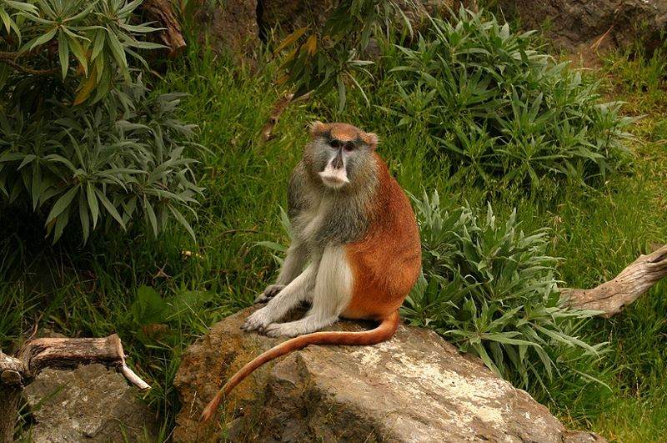

Olive Baboon

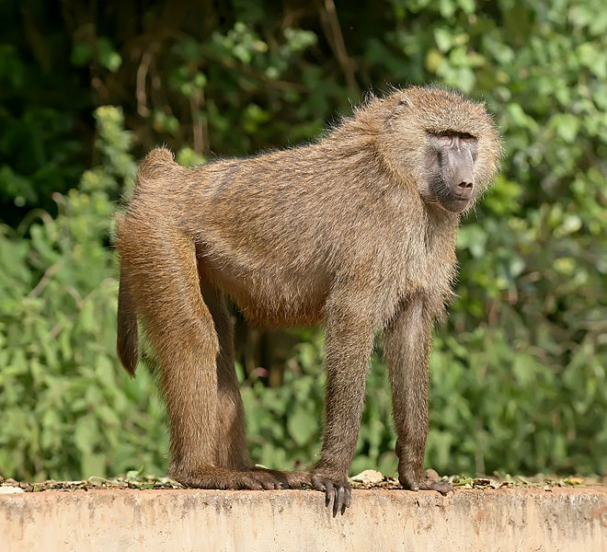

The olive baboon (Papio anubis), also called the Anubis baboon, is a member of the family Cercopithecidae (Old World monkeys). The species is the most widely ranging of all baboons: It is found in 25 countries throughout Africa, extending from Mali eastward to Ethiopia and Tanzania. Isolated populations are also found in some mountainous regions of the Sahara. It inhabits savannahs, steppes, and forests.

Bats:

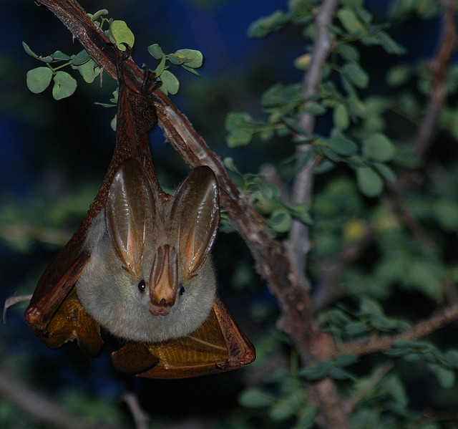Many different species of bats can be seen or heard in Serengeti National Park. They are very difficult to tell apart without recording equipment or catching animals.

Typical examples would be Horseshoe Bats of the genera Rhinolophus, named after their horseshoe-shaped main nose leaf, which is used for echolocation.  
They prefer savanna woodland and have, as all bats, a nocturnal lifestyle.

Insectivores:

**African Hedgehog**  
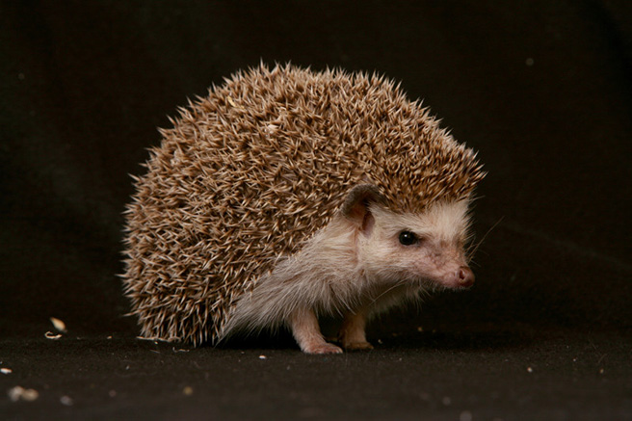

A typical hedgehog with boarded spikes covering its upper parts, while the under parts and face are white-haired. It is active during twilight and night, feeding on insects, worms, fruits and small vertebrates.

Probably resting from may to July, these solitary animals are mostly found on sandy terrain. When threatened they curl into a tight ball, offering only their spikes.

Hares:

Spring Hare

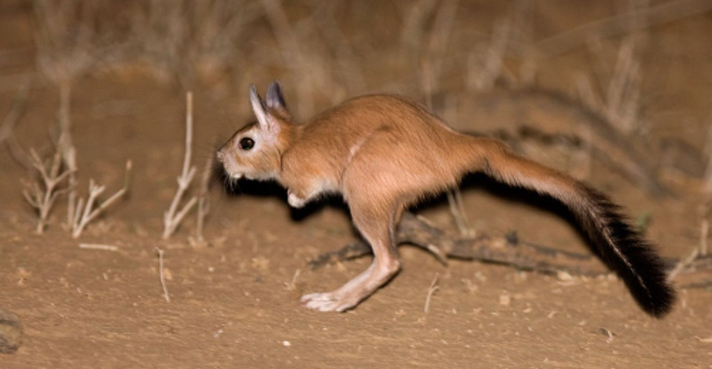

**Spring Hares**

Bouncing across the plains on long legs, the Spring Hare is actually not a hare at all, but a large rodent, reaching 4 kg in size. Spring Hares are common throughout south and eastern Africa, though they are seldom seen. These animals dig and live in a long burrow during the day, only emerging at night to feed on grasses and seeds.  
Groups of Spring Hares build warrens in undisturbed areas wherever there is abundant grass. They are most common along lake shores and in semi-wooded areas. They live and graze in groups of up to nine and can be quite a shocking site the first time you see one; "Am I in Australia?"   
You can tell the difference between Spring Hares and Cape Hares because Cape Hares are day time animals (diurnal) while Spring Hares are night animals (nocturnal). Spring Hares also run exclusively using their back legs very much like kangaroos, while Cape Hares run with all four legs.

Rodents:

Crested Porcupine

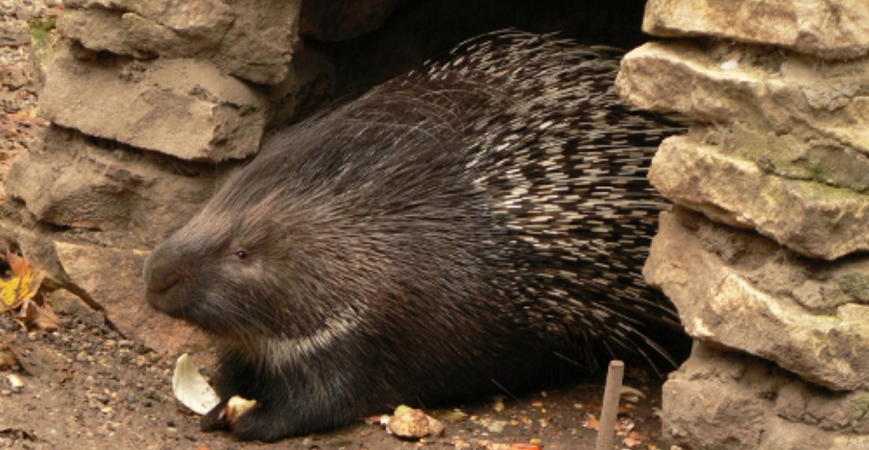

Crested Porcupine is a very large, black-bodied, nocturnal rodent with long, black and white spines and a prominent crest of elongated, spiny hairs from forehead to shoulders. It can be distinguished from others by its black rump and short, rattle-like quills in the tail. The forefeet have strong, digging claws and burrows are often the most obvious signs of its presence.

They are mostly seen in non-desert habitat in savannas, woodlands, steppes and uplands. The Crested Porcupine is sometimes found along forests margins. It prefers hilly or rocky country.

Crested Porcupine feeds on root, bulbs, bark and fallen fruits. Bones and dried animal remains are frequently gnawed, maize and cucumbers.

Family groups share a bullow or cave but foraging is a solitary activity during which an animal commonly travels up to 15km a night. Up to 4 young are born within the burrow. possibly twice a year. The babies are active and mobile at a month, suckled for 6-7 weeks and travel with the mother for about 1 year.

The hollow rattle-quills in the tail warn off potential preditors but their primary role is probably in communacation with other porcupines.

**C a r n i v o r e s:**

**The Genet**

A nocturnal catlike animal with a long, sleek body and striped tail, short legs and round ears.It has dark brown to black spots on the side and a stripe of black-tipped hair running down its back, which can be raised when alarmed.Like all genets, it emits a musky odour.

Feeding on invertebrates, small rodents, birds and reptiles, it is found in a wide range of habitats. Common Genets, which usually live solitary or in family groups, were kept as pets and to control mice in antic time.

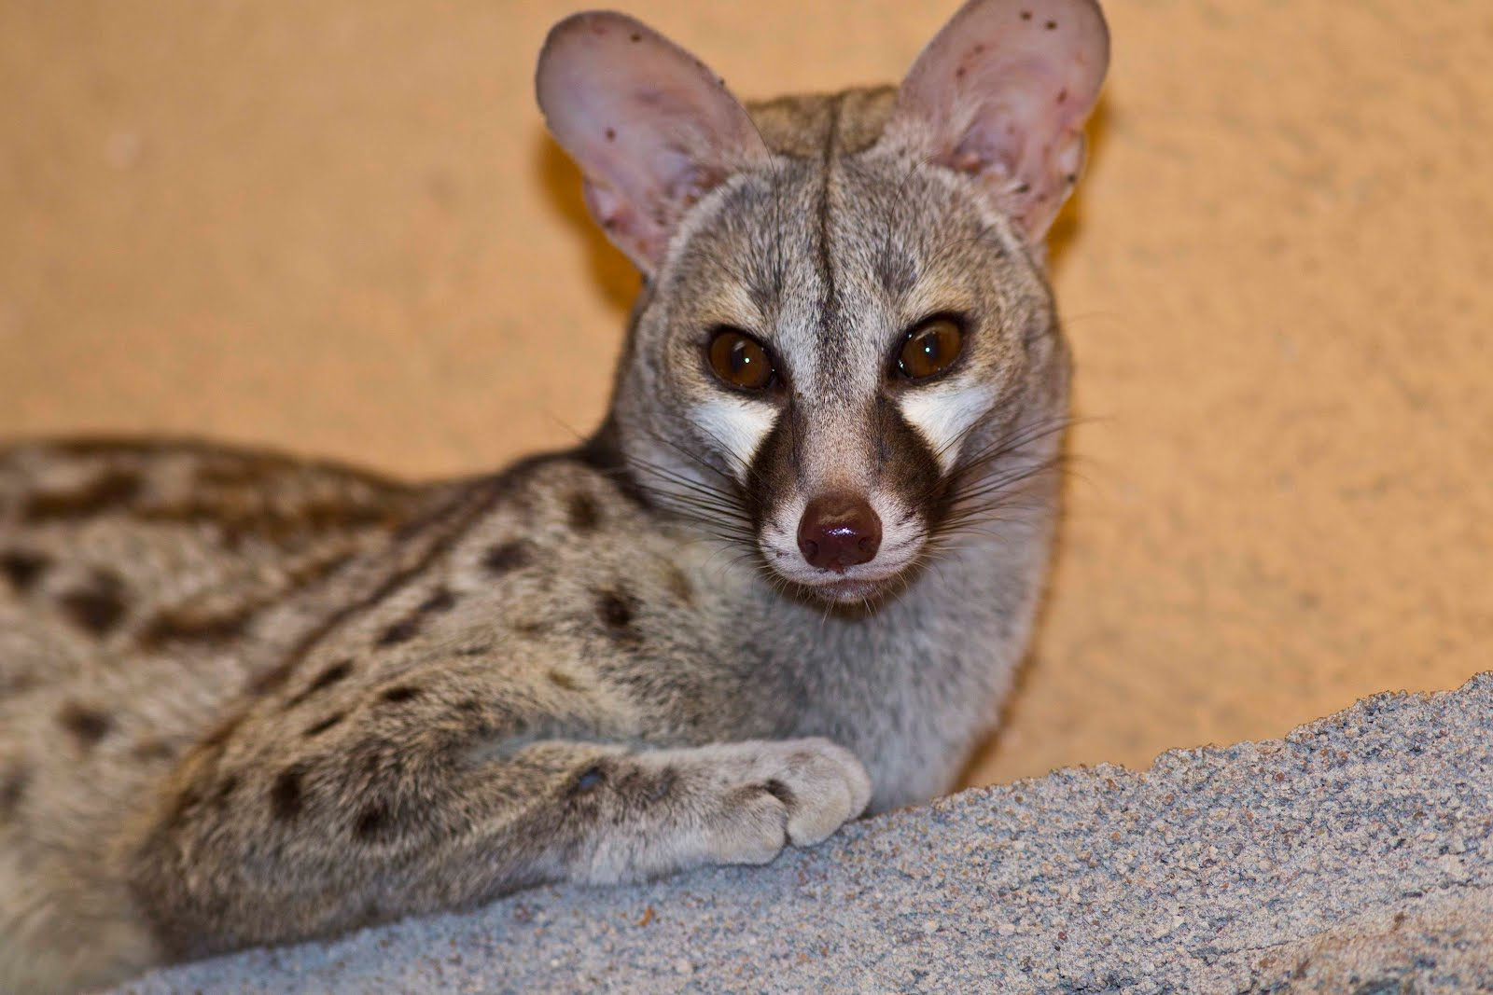

**Mongooses:**

**Marsh Mongoose**

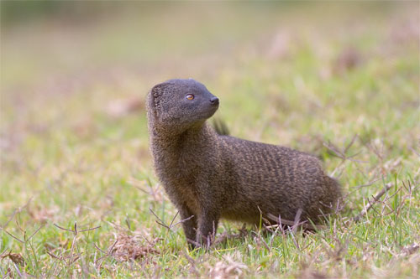

This medium-sized dark-brown animal is one of the more highly specialized mongooses. The neck, body and tail are covered with thick, shaggy fur while the fur on the hands and feet is short and sleek. The hand are extremely soft and sensitive and the thumb functions as a passive prop, enhancing the animal's purchase on a slippery surface. The premolar teeth are stout and used for crushing hard foods and the lower canines are particularly well-developed.

**Hyaenids, Hyaenidae and Protelinae**

**Spotted Hyena**

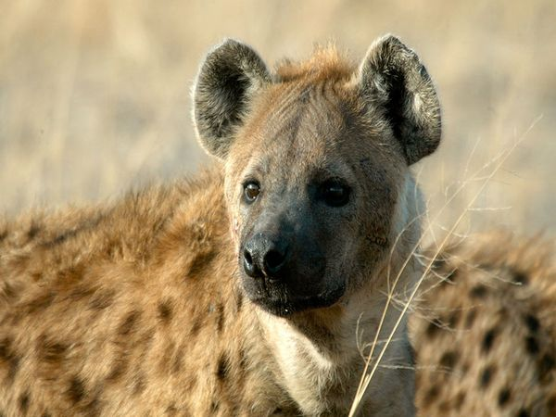

Spotted hyenas are famed scavengers and often dine on the leftovers of other predators. But these hardy beasts are also skilled hunters that will take down wildebeest or antelope. They also kill and eat birds, lizards, snakes, and insects.

In an increasingly overpopulated Africa, hyenas and humans come into frequent contact. In fact, the Maasai people of Kenya and Tanzania actually leave their dead to be consumed by hyenas. However, these intelligent and bold animals will raid food stores and crops and are blamed for many livestock and even some human deaths. In some areas they have been heavily hunted as destructive pests.

Cats:

**African Wildcat**

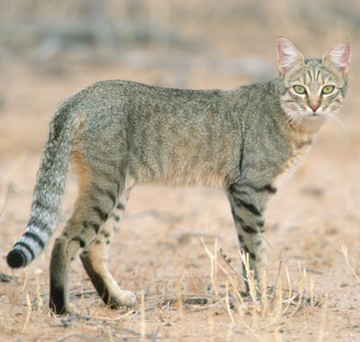

The African Wild Cat is similar in appearance to a domestic cat; however, it is proportionally larger and has longer hind legs. Cats in the drier western portion of the subregion are a light sandy ground colour with brown or rufous markings. In the eastern potion, they are light grey with charcoal or black markings; there is a wide area with intermediate colouring. A dark stripe runs along the midline of the back and neck, 2 distinct stripes circle the neck and there are 6-7 vertical stripes on the flanks. The legs are banded; markings are more distinct on lower limbs. Relatively long tail dark-ringed with black tip. Chin and throat are while and the chest in typically more pale than the rest of the body. Belly typically reddish. Backs of ears are coloured a rich reddish-brown. The average shoulder height is 35 cm. Total length is 85-100cm, tail 25-37cm. Weight is anywhere from 2.5-6.0kg.

Dogs:

Golden Jackal

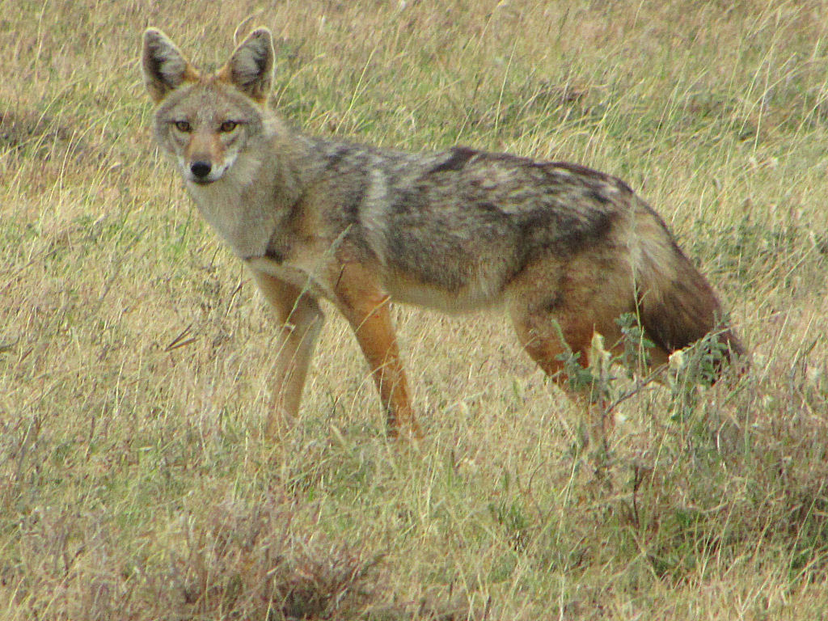The golden jackal occurs in North and East Africa, Southeastern Europe and South Asia to Burma. The body length of the golden jackal is 70 to 85 cm., with a tail length of about 25 cm. Its standing height is approximately 40 cm. The fur is generally coarse and not very long. Its coat is usually yellow to pale gold and brown-tipped, but the color can vary with season and region. On the Serengeti Plain in Northern Tanzania, golden jackals are brown-tipped yellow in the rainy season (December-January), changing to pale gold in the dry season (September-October).  
Weasels:

Zorilla

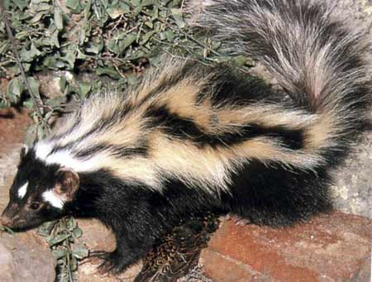

Striped polecats are found throughout the African continent. They are distributed in all habitats occurring between the Mauritanian coast and the coast of Sudan, and southward to the South African coastStriped polecats closely resemble the North American skunk. These small carnivores have glossy, coarse black fur with distinctive white spots on the face. There is a spot on the forehead and one on each cheek, and the black ears have white tips. Four broad white stripes extend down the body from the top of the head to the tip of the tail.

Ungulates:

Aardvark

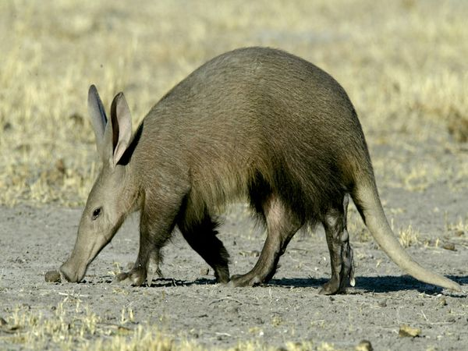

The name aardvark comes from the Africaan/Dutch meaning “earth pig”. This name is very fitting as the aardvark resembles a medium to large size pig and is an accomplished burrower. Aardvarks are considered a keystone species by some biologists because so many other animals are heavily reliant on their burrows for shelter.

The aardvark (Orycteropus afer) is the only living representative of an entire order of animals, the Tubulidentata.

Hyraxes:

Rock hyrax

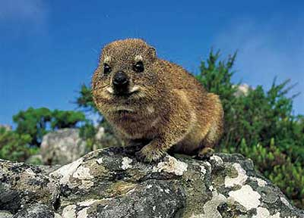

he hyrax, also called rock rabbit or dassie, is a small furry mammal. It looks like a robust, oversized guinea pig, or a rabbit with rounded ears and no tail. Hyraxes have stumpy toes with hooflike nails, four toes on each front foot and three on each back foot. The longer, clawlike nails on the inside toes of the back feet are used for grooming and scratching. The bottoms of the feet have a rubbery texture to assist in climbing steep rock surfaces and trees.  
  
Of the three hyrax species, two are known as rock (or bush) hyrax and the third as tree hyrax. In the field it is sometimes difficult to differentiate among them.

Pro Boscids:

Elephant

The African Elephant is the largest land animal, and at 3000-5000 kg, they weigh as much as four cars. Even to those used to seeing them, the shear size and bulk of elephants, especially at close range, is amazing. Both males and female elephants can push down full-grown trees in the search for food. They can also pick up the smallest seeds or nuts with their digit-like trunk.  
Elephants formerly ranged over most of sub-Saharan Africa. Due to increased land use by humans and illegal poaching pressure, though, they are restricted to remote areas and national parks and reserves. Today, elephants still range over a wide area of Africa, and a wide diversity of habitats, from swamps and forests, plains and savannas to the open Namibian desert.

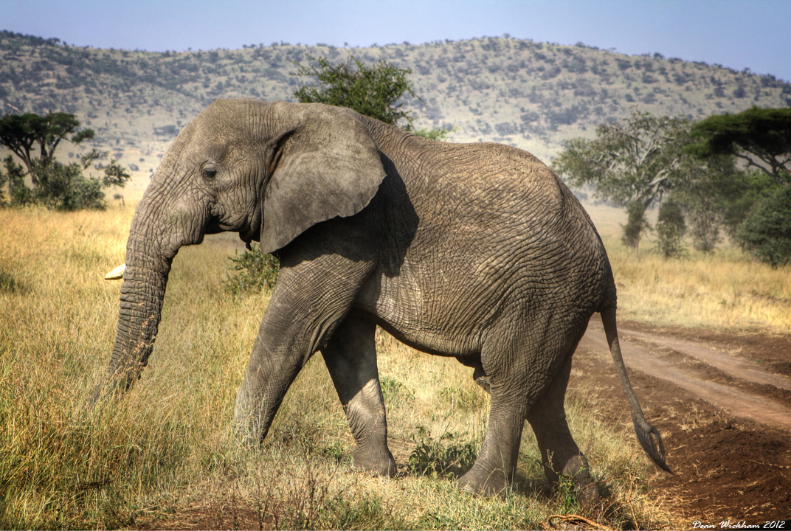

**Odd-Toed Ungulates**

**Even-Toed Ungulates**

**Spiral horned Bovines**

**Duikers**

**Gazelle**

**Reedbuck and allies**

**Horse-like Antelopes**

**Topis and allies**

**B i r d s**

**Reptiles:**

**Bats:**

**Elephant:  
Giraffe:**

**Impala:**

**Jackals:**

**Lyon:**

**Reedbucks:**

|  |  |  |  |
| --- | --- | --- | --- |
|  |  |  |  |